- Method and Step Introduction

- What is Tabu Search?

Tabu means prohibited, Tabu in this algorithm means to ban some local optimal solution for a while.

Tabu search nowadays is developed from local search, which is primarily from mountain climbing. About mountain climbing, it starts from a solution and finds the best one in its neighbor list, uses it to replace the current one, and we repeat this process many times to find the most optimal solution (mountain’s peak).
However, there arises a problem that we only search in one small region, so the final solution might probably not the best (global optimal).
Local search did some optimization base on mountain climbing, it changes the fitness function into finding the closest rather than finding the max/min, this may guarantee our direction to the global optimal is correct, but can not guarantee to reach that optimal.
So we here have the Tabu Search, which can change our solutions to different regions to avoid the local optimal and finally get the global optimal.

- What are the attributes of the Tabu Search:

The problem of how to extend the neighborhood, in this case, we use a technique called 1-opt that just swap 2 element nodes in an original path, which generates a neighborhood size of $N(N−1)/2$, this is, choosing the first swapping node we have N choices, and the second swapping node, we have N-1 choices, also, we have to deal with the repeating on <node1, node2>, so divide it by 2, or, you can also say that, for the first node, I have n-1 choices, the second node have n-2 and so on, the result is also n*(n-1)/2.
We say that Tabu search inherits the attributes of local search, that is, change the region of searching to avoid local minima, to do this, it will generate different primary solutions many times, and use each one of them to find neighbor and search.
- The third attribute about tabu search is naturally the tabu list, where it functions as a prison to lock up each local minima you found and releases one of them after every period of time. The reason we need a tabu list is that we do not want to choose repeated solutions and that very might happen in local search where two solutions have each other as the best neighbor, so we need to avoid such a situation.

- Now, we are going to talk about every component in the tabu search:
- Neighborhood.
We have a solution $x∈ D, where D is the feasible domain of x$, now we have a mapping N on D such that, $N∈ D^{∗}, where D^{∗} contains all the subset of D$, meaning, N is one of the subsets of D, now we say that N(x) is the neighborhood of x, and $y∈N(x) is one of the neighbors of x$.

- Candidate selection.
This is not required in Tabu since it just picks good solutions in the neighborhood to form a collection, in my case, I simply use the neighborhood selection to replace the candidate selection, it is much more convenient.

- Tabu list.
It merely contains 2 component {tabu object, tabu length}, in our cases, tabu list is a 2000*4 matrix where the first, second and third column represents the tabu object as the form <x, y, length>, where x and y is the index of swapped cities, and, the fourth column stores the tabu length, at first, we initiate every solution’s tabu length as 0, whenever we found that local minima, we set that solution’s tabu list value to “Max_Tabu_Size”, for example,
<x, y, length, Max_Tabu_Size> becomes one row of our tabu matrix.

- Fitness Function.
In our case, this is simply the total length of the path, if the return value is smaller, it means the solution is more optimal.

- Pardoning rule.
This one is also optional to tabu, our pardoning rule is very simple, assume you have a very long tabu length, and all of your local minima is locked up in the tabu list, so you can not get the global minima, at this time, the pardoning rule says that you can release one of the best solutions from all the solutions in the tabu list.

- Stopping condition.
If you want to be simple, you just set the loop times to be 100, you can have 100 times to repeatedly find a neighbor and add to tabu and do that all over again, in this process, you keep record the history. After 100 times, you just pick the best history solution as the global minima.
If you want this condition to be a little harder, there is another method: whenever a solution appears in the tabu list more than any time, you take it as you can never find a better solution, then you just pick out the best in the history as you did before.

- Jump out the local minima.
You just choose a few more random source solutions and do all the above steps few more times.

- Method Flow Chart
- Initialize the tabu list, that contains all the pairs of possibly swapped city nodes, and set all the lengths to infinity.
- Since we are going to jump to different regions, we set the total iteration time of the region changing to 25.
- After that, we generate an initial solution that is done by generating a random path of all the non-repeated cities. Also, calculate its length and store it into a variable temp.
- Then, we set the total iteration times to 100, meaning we are going to find the best solution in the neighborhood list 100 times, in each region. In each iteration, if the current best solution is in the tabu list, we set it to the pardon. Otherwise, we just renew the length in the tabu list for this particular pair of nodes.
- After renewing the length of the entire tabu list, we just traverse it and pick out the best solution as the local minima and record it in the tabu list, and we update the current solution to this local minima and keep searching the neighborhood.
- After updating the current minima, we update the length of the tabu list by tabu.size=tabu.size-1.
- For each region, we compare the old global minima to the new global minima and finally pick the optimal one.

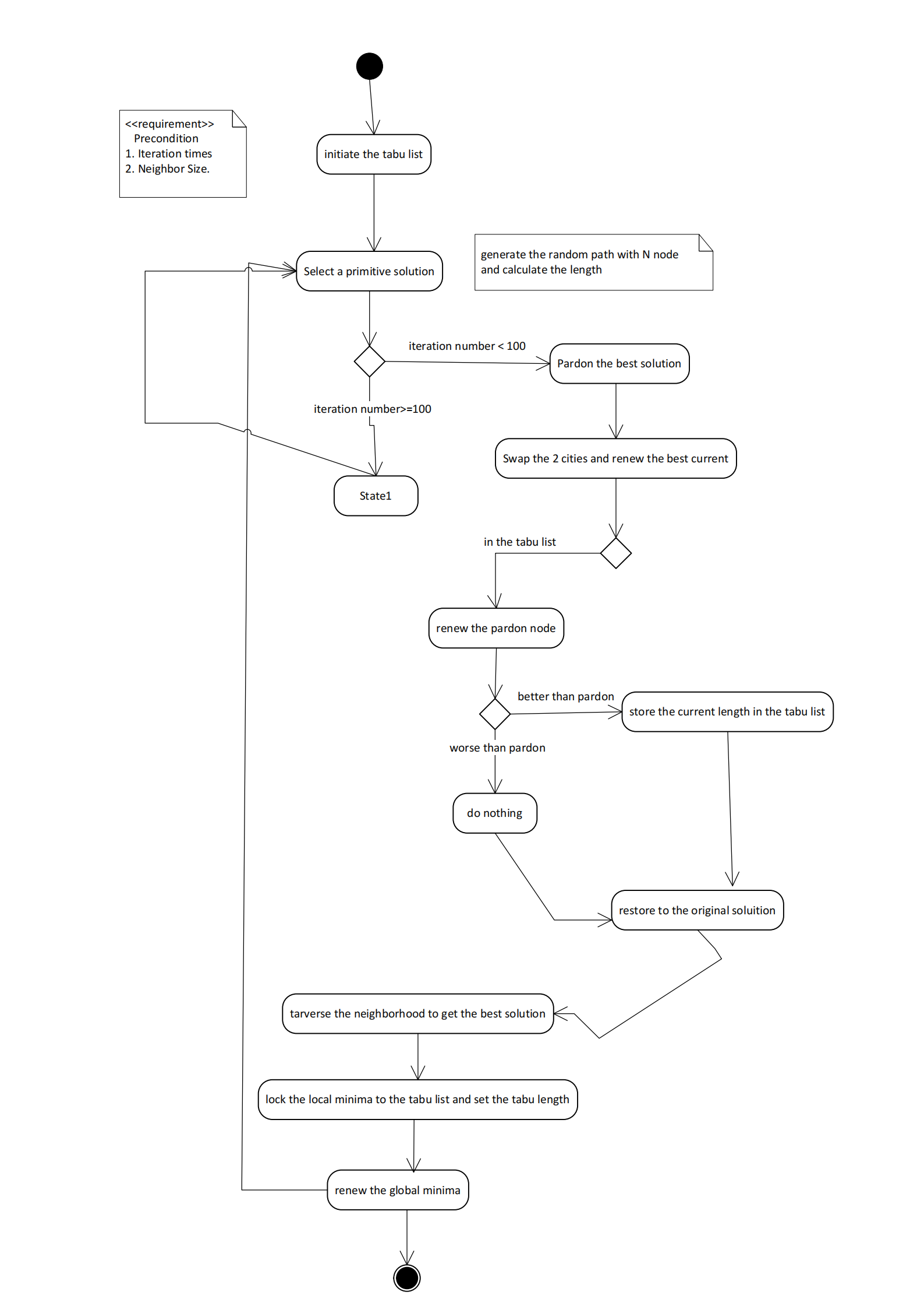

- Design Detail.
We’ve talked about a lot of details before. One characteristic is the tabu list
Vertex index i | Vertex index j | Path length | Tabu duration
..... | ...... | ...... | .....
In addition to the structure, since we have 50(50-1)/2 solutions (we talked before, choose 2 points to swap without order $C_{n}^{2}$, do not mix this with generating source solution because the solution for this problem is also n*(n-1)/2, but the meaning is different, this means the number of paths that we can randomly generate.

For example, if we have 5 cities, the tabu list looks like this:
1 | 2 | 10 | 4
2 | 3 | 11 | 3
3 | 4 | 12 | 2
4 | 5 | 13 | 1

For other details, generate source solution is very important, it affect your efficiency of jumping to different region.
//generate(without repeat)random city order
void CreateRandOrder(int* city, const int& N) {
for (int i = 0; i < N; i++) {
city[i] = rand() % N;
for (int j = 0; j < i; j++) {//search whether there is repeat，if exist，regenerate.
if (city[i] == city[j]) {
i--;
break;
}
}
}
}

For large N, the worst case is to search N-1 times each time generate a new value, this from N-1 to 1, (N-1)N/2 in total, for each node with seq number N, so we can have $\sum_{n=2}^{N}{\frac{n∗(n−1)}{2}=}$
$\frac{\frac{(n+1)(2n+1)n}{6}−1−(\frac{n(n−1)}{2}−1)}{2}$=$O(n^{3})$.

Now I am giving you the entire procedure of tabu.
int countI; //iteration times
int countN; //size of neighbor list
int NEIGHBOUR_SIZE = N * (N - 1) / 2; //size of neighbor list

double bestDis; //bestDis==local minima
double curDis; //curDis==best neighbor
double tmpDis; //tmpDis==distance after swapping
double finalDis = INF; //finalDis==gloabal op1timal

There is some variable used later.

- Initialize Tabu List
- predefine "all possible neighborhood (possible swapping index)" column 0 and 1 are the swapping vertices，
- column2 is the path length after swapping，
- column3 is tabu duration.

int i = 0;
for (int j = 0; j < N - 1; j++) {
for (int k = j + 1; k < N; k++) {
tabuList[i][0] = j;
tabuList[i][1] = k;
tabuList[i][2] = INF;
i++;
}
}

- Tabu body (incomplete code representation)
double TabuSearch(const int& N) {
Initialize.........

Initialize tabu list.....

Jump out the local minima for 25 times
for (int t = 0; t < 25; t++) {

CreateRandOrder(city1, N); //get a random path(source solution)
bestDis = GetPathLen(city1, N); //initialize best neighborsolution

countI = ITERATIONS;//100
int a, b; //store the indexes of 2 cities
int pardon[2]; //pardon--->set one solution free, basically the best in the //tabu list
int curBest[2]; //best neighbor

100 times expanding region for each region
while (countI--) {

countN = NEIGHBOUR_SIZE;//N*(N-1)/2
pardon[0] = pardon[1] = curBest[0] = curBest[1] = INF; //initialize best //neighbor and pardon solution
memcpy(city2, city1, sizeof(city2)); //copy city1 into //city2, very convenient for swap
Traverse neighborhood
while (countN--) {

Get 2 cities’index
a = tabuList[countN][0];
b = tabuList[countN][1];
swap(city2[a], city2[b]); //swap 2 vertex on this path

Get 1 neighborhood solution
tmpDis = GetPathLen(city2, N);// get new path's length
//if the new solution is in the tabu list，just update the pardon solution
if (tabuList[countN][3] > 0) { //if the solution is in tabu duration
tabuList[countN][2] = INF;
if (tmpDis < pardon[1]) {
pardon[0] = countN;
pardon[1] = tmpDis;
}
}

else {

tabuList[countN][2] = tmpDis; //store the neighborhood solution
}
swap(city2[a], city2[b]); //recover to the source solution**
}
//traverse the neighbrhood and find the best
for (int i = 0; i < NEIGHBOUR_SIZE; i++) {
if (tabuList[i][3] == 0 && tabuList[i][2] < curBest[1]) {
curBest[0] = i;
curBest[1] = tabuList[i][2];
}
}
//pardon solution
if (curBest[0] == INF || pardon[1] < bestDis) {
curBest[0] = pardon[0];
curBest[1] = pardon[1];
}

//update local minima
if (curBest[1] < bestDis) {
bestDis = curBest[1];
tabuList[curBest[0]][3] = TABU_SIZE;
bestIteration = ITERATIONS - countI;

Get local minima’s swapping index
a = tabuList[curBest[0]][0];
b = tabuList[curBest[0]][1];

update the source solution to local minima
swap(city1[a], city1[b]); }

UpdateTabuList(NEIGHBOUR_SIZE); //update tabu duration

}//100's iteration over

Update global minima
if (bestDis < finalDis) {
finalDis = bestDis;
memcpy(path, city1, sizeof(path));// record the current global minima
}

}
return finalDis;
}

Some implementations I did not show here.

- Experimental procedure.
First, we input 10 cities and their relative distances between each other and put those data into a text file, then, we use “ifstream” class in C++ to read those data from a text file to a matrix we created called adj.
for (k = 0; k < SampleSize - 1; k++)
{

for (j = k + 1; j < SampleSize; j++) {
infile >> adj[k][j]; //read from file

}
}

In this part of the code, we only store the upper half triangular matrix, this is because we only need this part for "Undirected Complete Graph", the diagonal and the lower triangle should be set as 0. after all, a self-loop can not exist in the UDG.

After we click run, the result would be:
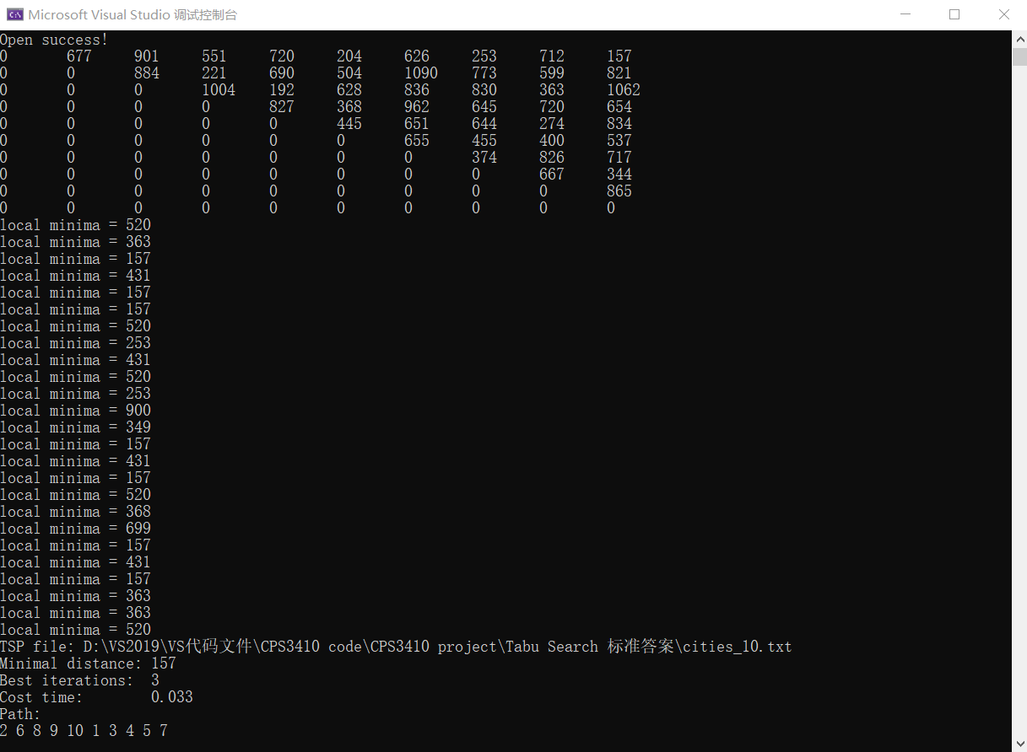
It first prints an undirected complete graph, then shows the directory of the city information file, then it shows all the local minima during 50 times' iteration, and finally it prints the local minimal distance as well as the optimal path of these cities.

- Assessment:
There is nothing new in the preparation of Tabu search, for example, the creation of the graph, which takes O(n^2), the overall complexity of tabu search is variable along with the size of the tabu list and the neighborhood structure you choose, as well as the stopping condition and pardon rules, in our example, the neighbor structure is 1-opt, which means search the neighborhood takes O(n^2), in other examples, maybe Hamilton circuit, it is also O(n^2), there are the basic steps of constructing Hamilton Circuit:

In the tabu method itself, initialize the tabu list spends O(N) where N is the size of the tabu list. However, for generating source solution, there are two assortment:
void CreateRandOrder(int* city, const int& N) {
for (int i = 0; i < N; i++) {
city[i] = rand() % N;
for (int j = 0; j < i; j++) {//搜寻是否有重复，如果有的话，重新生成
if (city[i] == city[j]) {
i--;
break;
}
}
}
}
If things go well, every city generated is not repeating the previous one, that requires 1+2+...+N-1, which is O(n^2), however, if every selection of a city is a repeat of the previous one, that is $\sum_{i=1}^{n}{\frac{(n−1)∗n}{2}}$, and this can be approximated by $\sum_{i=1}^{n}{x^2}=\frac{n(n+1)(2n+1)}{6}$=O(n^3). however, this is still not the worst case, if the guy does not have any luck, he will stick at the second city forever because it is random.

Getting the distance is only O(n), it does not affect at all, and, when you get the results of all the neighbor solutions, you need to traverse them and find the best neighbor, which takes O(n) where n is the size of the neighborhood structure.
Another very important influence factor is the neighborhood iteration times you set, in my case, it is 100, in someone else’s, stopping condition is when some good solution appears more than constant times, and this is hard to evaluate.

- Quality of obtained solution.
I take my 50-city solution for instance. Set region iteration to 50, set neighborhood iteration to 100, set tabu list size to 200.

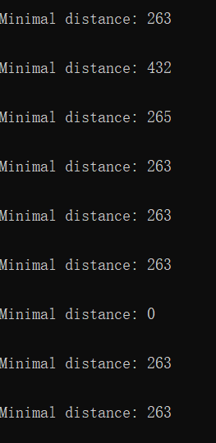
We iterate tabu search for 10 times and find that there is a value of the minima path showing 0, but mostly they are 263, so the optimal solution is relatively stable.

Now we iterate the tabu search 1000 time, and get an overall tendency:
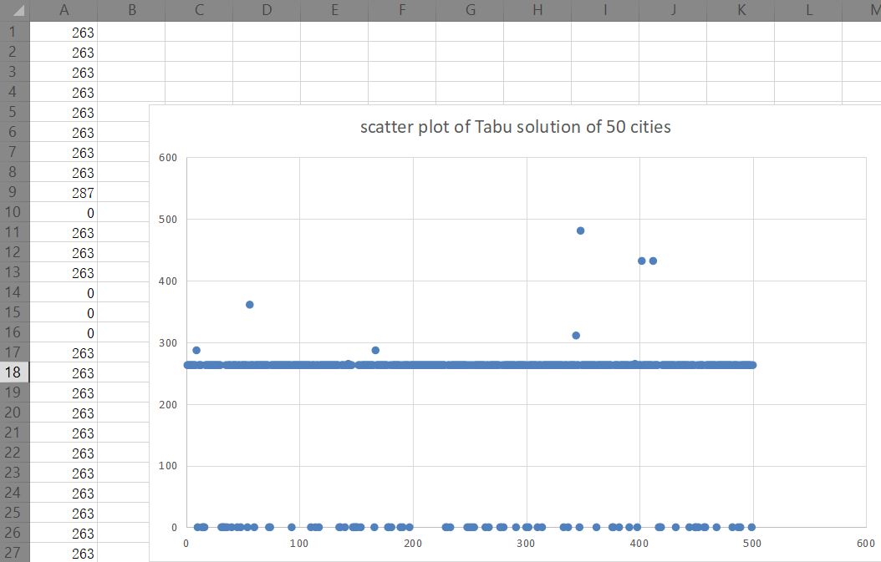

Most of the solution is exact 263, except some 0 and some beyond 263. from this performance we can give the conclusion that the quality of the solution is relatively high.

- Convergence time.
For this assessment, we need a bigger set of cities, if we only use 50 cities, the result will be it will always convergent to 263 and 264 (to be specific, this is oscillating and never convergent, however, we are doing approximation)

- Stability
Stability for sorting algorithm means that no matter you use what key to do the sorting, the relative position will remain unchanged, for example, stem-leaf in bucket sort, you first sort leaf, and then sort stem, the relative order of sorted leaf will not change just because you sort the stem.
In our case, whenever we swap 2 cities in the neighborhood, we get the distance and then we restore the original order until reaching the local minima, then we permanently change the order. So the stability is very high. You can also see this from the output.

- Discussion and conclusion.
Tabu search works as an improvement as the local search, it greatly avoid local minima and try to use the tabu list to reach the global minima, however, we can see that the performance of tabu is restricted by the length of the tabu list, the stopping condition and self-set iteration times, so the total performance for different set up is very unstable, but for a single set up, and relatively small data set, it recognizes global optimal in a very short time.

